Database Project : Phase 1
TA : Dina Amr
Name – ID – Lab Group :
- Mena Sultan - 20244068 – G1
- Ahmed Hasanien - 20246011 – G12
- Esmail Khetam - 20246019 – G12
- Abdelrahman Zayed - 20246066 – All (G12)
- Abdelrahman Elnaggar - 20246011 – G12
- Sayed Ahmed – 20257000 - All (G12)
Program : Special Zayed

Step 1 : Data Source
- Kaggle Link : https://www.kaggle.com/datasets/joycemara/european-fashion-store-multitable-dataset?select=dataset_fashion_store_campaigns.csv
Step 2 : Data Dictionary
1. Data Source
This dataset belongs to TIVA — a women's fashion brand selling online across 6 European countries:
France • Germany • Italy • Spain • Netherlands • Portugal
The data covers the period from April 2025 to June 2025, and includes sales transactions, customer profiles, product catalog, warehouse stock, and marketing campaigns.
2. Files Overview
The dataset consists of 7 interrelated CSV files:

File | Each Row Represents... | Rows | Columns
products | A single product in the catalog | 500 | 10
sales | A complete sales invoice for a customer | 905 | 7
salesitems | A single product line within an invoice | 2,253 | 13
customers | A registered customer in the system | 1,000 | 4
stock | Stock quantity of a product in a specific country | 1,000 | 3
campaigns | A marketing campaign (discount or offer) | 7 | 7
channels | A sales or marketing channel | 5 | 2

3. Column Descriptions
3.1 products — Product Catalog
Column | Type | Description
product_id | INT | Unique product identifier (Primary Key)
product_name | TEXT | Product name
category | TEXT | Category: Dresses / T-Shirts / Pants / Shoes / Sleepwear
brand | TEXT | Product brand name
color | TEXT | Product color
size | TEXT | Size (S, M, L, XL, or numeric)
catalog_price | FLOAT | Selling price to customer (in Euro)
cost_price | FLOAT | Company purchase cost (in Euro)
gender | TEXT | Target gender (Female only in this dataset)
size_type | TEXT | Size format: Alpha (S/M/L) or Numeric (36/38/40...)

3.2 sales — Sales Invoices
Column | Type | Description
sale_id | INT | Unique invoice identifier (Primary Key)
channel | TEXT | Sales channel: E-commerce or App Mobile
discounted | INT | Was a discount applied? (1 = Yes, 0 = No)
sale_date | DATE | Date of sale (April to June 2025)
customer_id | INT | Customer identifier (Foreign Key -> customers)
country | TEXT | Customer country (6 European countries)
total_amount | FLOAT | Total invoice value in Euro

3.3 salesitems — Invoice Line Items
Column | Type | Description
item_id | INT | Unique line item identifier (Primary Key)
sale_id | INT | Associated invoice (Foreign Key -> sales)
product_id | INT | Product sold (Foreign Key -> products)
quantity | INT | Quantity purchased
original_price | FLOAT | Original price before any discount
unit_price | FLOAT | Actual price after discount applied
discount_applied | FLOAT | Discount amount in Euro
discount_percent | FLOAT | Discount percentage (%)
discounted | INT | Was a discount applied? (1 = Yes, 0 = No)
item_total | FLOAT | Line total = unit_price x quantity
sale_date | DATE | Date of sale
channel | TEXT | Sales channel
channel_campaigns | TEXT | Name of the associated marketing campaign

3.4 customers — Customer Profiles
Column | Type | Description
customer_id | INT | Unique customer identifier (Primary Key)
country | TEXT | Country (France, Germany, Italy, Spain, Netherlands, Portugal)
age_range | TEXT | Age group: 16-25, 26-35, 36-45, 46-55, 56-65
signup_date | DATE | Date the customer registered in the system

3.5 stock — Warehouse Stock
Column | Type | Description
country | TEXT | Country
product_id | INT | Product (Foreign Key -> products)
stock_quantity | INT | Available quantity in warehouse

3.6 campaigns — Marketing Campaigns
Column | Type | Description
campaign_id | INT | Unique campaign identifier (Primary Key)
campaign_name | TEXT | Campaign name (e.g., Spring Flash Sale)
start_date | DATE | Campaign start date
end_date | DATE | Campaign end date
channel | TEXT | Campaign channel (Email, Social Media, App Mobile, Website Banner)
discount_type | TEXT | Discount type: Percentage or Fixed
discount_value | FLOAT | Discount value (% rate or fixed Euro amount)

4. Key Statistics
• Total sales invoices: 905
• Total product line items sold: 2,253 rows in salesitems
• Total registered customers: 1,000
• Total products in catalog: 500
• Average invoice value: 358 Euro
• Minimum invoice: 45.49 Euro — Maximum invoice: 859.38 Euro
• Sales channels: E-commerce and App Mobile only
• Marketing campaigns: 7 campaigns across the period

Step 3 : The Problems
- Who is the user :
Regional Sales Manager
- What are the problems :
1. Revenue Trends Over Time
Problem: How is the total revenue trending month-over-month to identify peak sales periods?

2. Top Performing Product Categories
Problem: Which product categories (e.g., Dresses, T-Shirts) are generating the most revenue?

3. Profitability Analysis by Category
Problem: High revenue doesn't always mean high profit. Which categories have the highest profit margins?

4. Customer Demographics (Age & Gender)
Problem: Who is our primary customer? Understanding the age and gender split of our revenue.

5. Sales Channel Effectiveness
Problem: Which sales channels (App, E-commerce, etc.) are the most effective at driving sales?

6. Geographic Sales Distribution
Problem: Which countries are contributing the most to global sales?

Step 4 : Interactive Dashboard
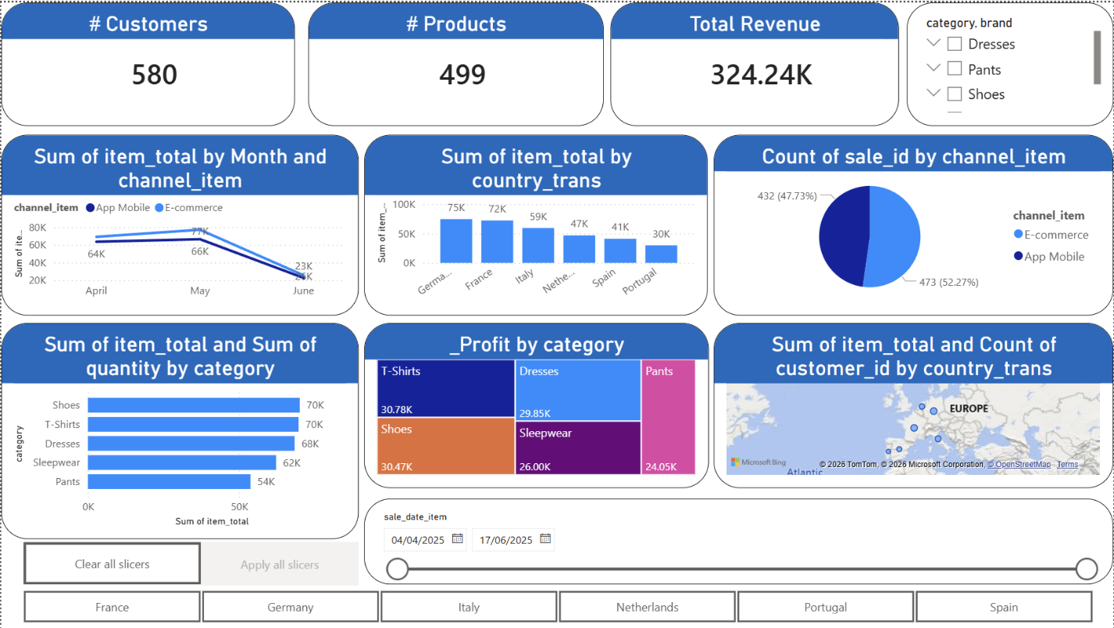
- Full Interactive Dashboard is in the Power BI File in the Folder
Step 5 : Detailed Report
When evaluating the month-over-month performance, the business experienced a significant drop in high-level metrics. Total revenue fell from $143,471.34 in May to $48,177.37 in June, representing a 66.4% overall drop.
- T-Shirts: Revenue fell from $32,199.49 down to $10,221.21, resulting in the largest absolute drop of -$21,978.28 (a 68% decrease).

- Shoes: Revenue fell from $30,869.00 down to $9,838.22, resulting in an absolute drop of -$21,030.78 (a 68 % decrease).

- Sleepwear: Revenue fell from $27,811.44 down to $8,764.49, resulting in an absolute drop of -$19,046.95 (a 68 % decrease).

- Dresses: Revenue fell from $28,343.12 down to $11,671.43, resulting in an absolute drop of -$16,671.69 (a 58 % decrease).

- Pants: Revenue fell from $24,248.29 down to $7,682.02, resulting in an absolute drop of -$16,566.27 (a 68 % decrease).
( Report available in PowerBI File)
Step 6 : Recommendations
​Based on the performance trends identified in the interactive dashboard and the granular findings of the detailed report, the following two actionable recommendations are proposed to stabilize revenue and optimize future sales:
​1. Implement a Targeted "Volume Recovery" Sale for High-Impact Categories
- ​The Insight: The detailed report indicates a severe 66.4% overall drop in revenue from May to June.
- ​The Specifics: Three major categories—T-Shirts, Shoes, and Sleepwear—each experienced a massive 68% revenue decrease, with T-Shirts alone accounting for a loss of $21,978.28.
- ​Actionable Step: To clear remaining inventory and regain momentum, the business should launch a "Buy One, Get One" (BOGO) or a 30% discount campaign specifically for T-Shirts and Shoes. This promotion should be timed for early July to counteract the sharp decline observed throughout June.
​2. Optimize Mobile App Engagement in Top European Markets
- ​The Insight: The dashboard reveals that the App Mobile channel is a significant driver of business, representing 47.73% of all sales.
- ​The Specifics: Germany and France are clearly the top-performing countries by "Sum of item_total".
- ​Actionable Step: The marketing team should deploy localized mobile-push notifications and app-exclusive offers tailored to users in Germany and France. By leveraging the high mobile engagement in these high-volume regions, the business can more effectively stabilize the declining sales trend seen in the transition from May to June.

